EX-MS11   
Javascript Assignment # 4

Javascript | 24/01/21

1. Make a program that will filter out all the even numbers  
   const numbers = [1, 3, 4, 6, 8, 9];

Code:

var consnumber = [1,3,4,6,8,9];

function filterfn(consnumber){

return (consnumber % 2 == 0)

}

consnumber.filter(filterfn)

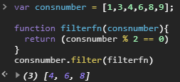

9. We need to store studentData into a variable, which data type we will be using to store that ? Could you make that variable & store these values   
- firstName   
- lastName  
- rollNumber  
- className  
- midtermScore  
- finalScore  
- hasClassRepresentativeRole

**ANSWER;**

var students = ["studentdata","teacherdata"]

studentdata = {

Firstname : 'bilal',

Lastname : 'alam',

rollnumber :  '68',

classname: 6,

midtermscore:92,

finalscore:100,

hasClassRepresentativeRole:true

}

The data type is known as object As you can see here studentdata is an object and the entries of it are its properties or value .

In object we can store multiple value